**SERPENT BOT**

**Team Slytherin**

Adithya Adiga – 1BM20IS010

Bhojraj Anand Kumbar – 1BM19ME033

Bukkapatnam Meghana – 1BM19EI017

Prachetha P Vasishta – 1BM19EC105

Sree Suryadatta M Vadhoolas – 1BM19EC161

**Concept:**

The Serpent Bot is a mimic to the actual Snake which is capable of different modes of reptile locomotion. It is a wireless Wi-Fi controlled Bot whose motion is controlled by an Android Application. This simple Robotic model of a Snake has various use-case applications from a simple children toy to many Medical, Surveillance, Disaster management applications. Traditional Snake Bots locomote purely by changing the shape of their body, just like snakes. Many variants have been created which use wheels or treads for locomotion. No Snake Bots have been developed yet that can completely mimic the locomotion of real snakes, but researchers have been able to produce ways of moving that do not occur in nature. Hence this simple project’s objective is to mimic the near similarity to Slithering Motion.

**Components:**

The Components used for the Serpent Bot Model include various Structural and Electrical parts which are:

*3D Model:* The Structural part of the bot which holds all the other parts of the Bot, designed in multiple segments to assume Snake like Structure and supports the Serpent motion.

*NodeMCU:* The ESP8266 NodeMCU module is a built-in Wi-Fi Microcontroller used to control the Snake Motion according to the Commands received through Wi-Fi.

*SG90 Servo Motors:* The Servo Motor is a feedback-controlled Motor with 180° range of angle control. This is used to precisely control the Snakes’ joints for the appropriate snake motion according to the commands received.

*PCA9685 PWM driver:* The 16-channel Pulse width modulation driver controlled using I2C communication. This module is used to drive Servo motors to provide the appropriate PWM, which is controlled by the I2C line from the NodeMCU.

*Lithium-ion batteries:* The rechargeable power source the Servo drivers, NodeMCU microcontroller and other modules on the Serpent Bot.

*Buck Regulators:* The DC-to-DC voltage converters with adjustable output to provide suitable power conversion from Li-ion batteries to the NodeMCU.

Other components such as the jumper wires, Battery casing, and components for testing purpose.

**Project Scope:**

There are few qualities that all Snake Bots share:

1. First, their small cross section to length ratio allows them to move into, and maneuverer through, tight spaces.
2. Second, their ability to change the shape of their body allows them to perform a wide range of behaviours, such as climbing stairs or tree trunks.
3. Additionally, many snake robots are constructed by chaining together a number of independent links. This redundancy makes them resistant to failure, because they can continue to operate even if parts of their body are destroyed.
4. The locomotive flexibility of Snake Bots makes them useful to operate in different terrestrial conditions.
5. Snake Bots can move on difficult geographical reliefs like mountain or hilly surface, deserts, rough terrains, wild forests underground and in narrow & difficult places like pipes, drains, gaps, holes, sewers and can climb trees, pipes, ladders, etc.
6. Snake is one of the creatures that exhibit excellent mobility in various terrains.
7. Snake robots most often have a high number of degrees of freedom (DOF) and they are able to locomote without using active wheels or legs.
8. In comparison to wheeled and legged mobile robots, the snake robots have high stability and good terrainability. The exterior can be completely sealed to keep dust and fluids out.

There are many applications for a Serpent like Bot due to its terrainability and wide range of motion behaviour, to mention a few are:

1. Rescue missions in earthquake area: The snake robot could crawl through destroyed buildings looking for people. It could also carry small amounts of food or water to people trapped by the building prior to the arrival of rescue personnel.
2. The snake robot can also be used for surveillance and maintenance of complex and possibly dangerous structures such as nuclear plants or pipelines.
3. In a city, it could inspect the sewer system looking for leaks or aiding fire-fighters.
4. NASA engineers are developing an intelligent robot snake that may help explore other worlds and perform construction tasks in space. The Snake Bot, able to independently dig in loose extra-terrestrial soil, smart enough to slither into cracks in a planet’s surface and capable of planning routes over or around obstacles.

**Hardware Architecture:**

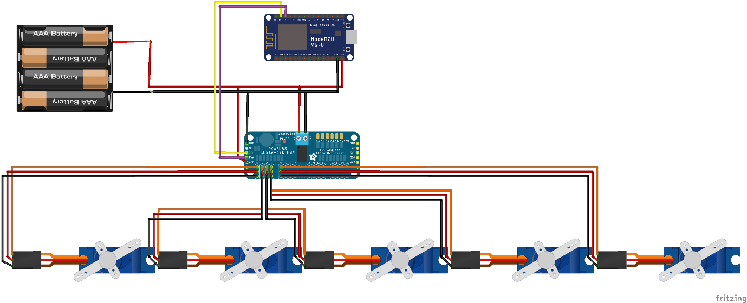

The hardware of snake bot primarily consists of 3D printed links (in this case 5), motion between which is controlled by the Servos (SG90). The Servo motors are driven by a PWM driver (PCA9685), the value for which is controlled by the I2C lines. The value for each channel (Servo), for serpentine motion is calculated and transmitted in the I2C lines by the NodeMCU microcontroller. On the top, the Wi-Fi application communicates with the NodeMCU to provide motion commands.

Connections:

Power: 5V supply to be given to NodeMCU and 5-7V for PCA9685 I2C PWM driver. Hence, few Lithium-Ion Batteries to be used along with Buck Regulators if necessary.

I2C: The D2 (SCL) pin and D3 (SDA) pin of NodeMCU constitute the I2C bus, which is connected to the SCL and SDA pins of driver.

Servo Motor: it consists of Power, Ground and Control pins which can be directly plugged to the male pins on the driver board.

**Software Architecture:**

Start

While 1

If command received (Wi-Fi)

no

yes

Command-value: f/b/l/r/s?

no

End

Write Servo angles via I2C: Move according to command

Calculate Angles for Servos: forward/backward/right/left/stop

**Current Progress:**

1. Understood the concept of Serpent motion and implemented in a Tinker CAD Simulation for different Slithering Motions.
2. Designed the Test model of the 3D block of Servo housing/Snake body.
3. Procured all components for testing and prototyping of the design idea.
4. Obtained the first Test block of the Snake body after 3D printing.

**References:**

1. <https://www.instructables.com/Snake-Robot-1/>
2. <https://en.wikipedia.org/wiki/Snakebot>
3. <http://www.iosrjournals.org/iosr-jce/papers/Vol17-issue5/Version-1/B017510306.pdf>
4. <https://www.nasa.gov/centers/ames/news/releases/2000/00_66AR.html>